For assistance filling out your forms, please follow these steps:
- Before you begin, please ensure you have Adobe Acrobat Reader on your computer. (You can do so by clicking on the Search bar at the bottom of your screen and typing in “Adobe Acrobat”.
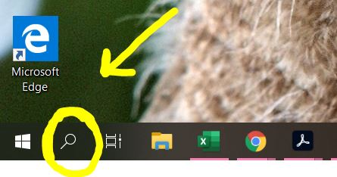
- If Adobe is not listed as an option, please download it for free here.

- Navigate back to “New Client Forms” and click on the form you’d like to open. Then, select the "Download" icon (upper right corner, showing an arrow point downward).
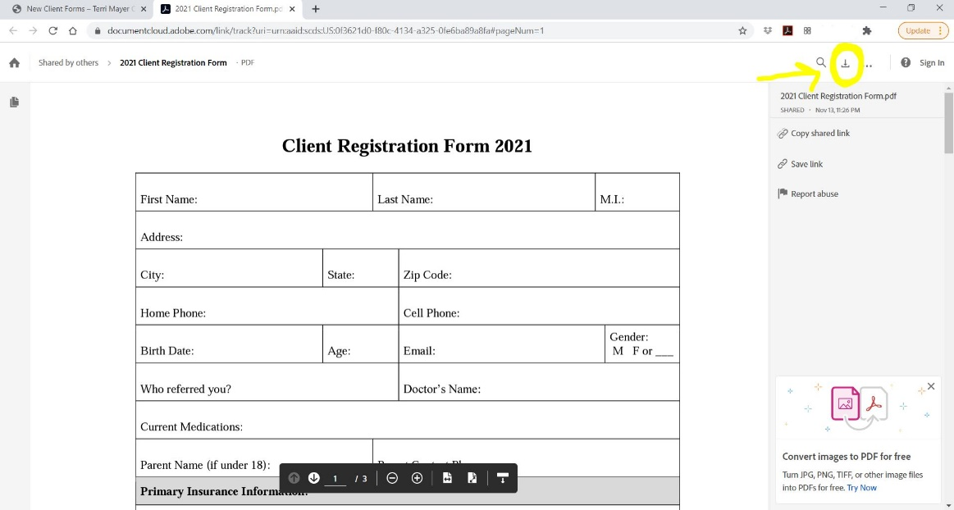
- Double click the download in the bottom left of your screen to open in Adobe Acrobat Reader.
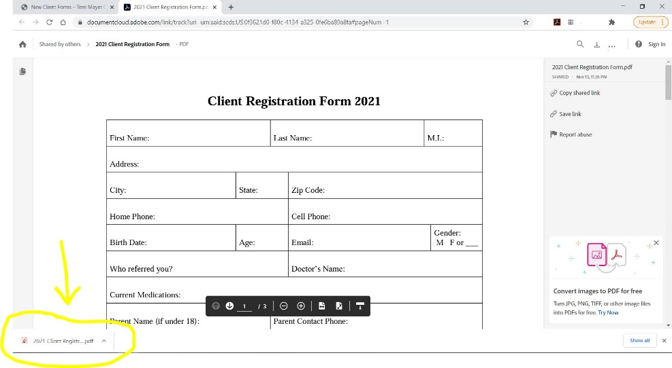

- If the form does not automatically open in Adobe Acrobat Reader, please follow these steps.
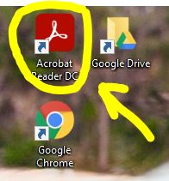
  - Minimize the website page and open Adobe through clicking on your homepage icon (shown below), or redoing your search from earlier and double clicking on Adobe Acrobat from the list. (Note, your homepage icon may look slightly different or be a different color depending on which version you are using.)

  - Once in Adobe, select File, Open.
  - Click on the Downloads folder in the left-hand menu. The form you are trying to fill out should be listed. Double click on the file to open.

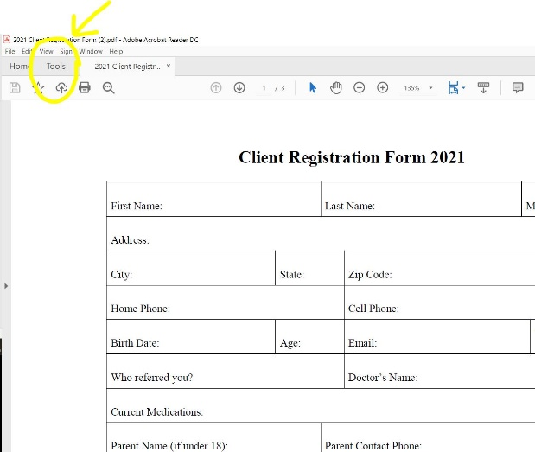
- Once you have the form open in Adobe, select the "Tools" tab.

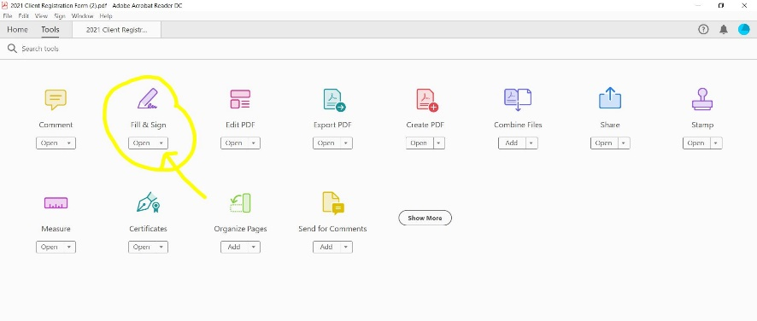
- Then select Open under the "Fill and Sign" app. If prompted by a “What do you want to do?” page, select the “Fill and Sign” option.

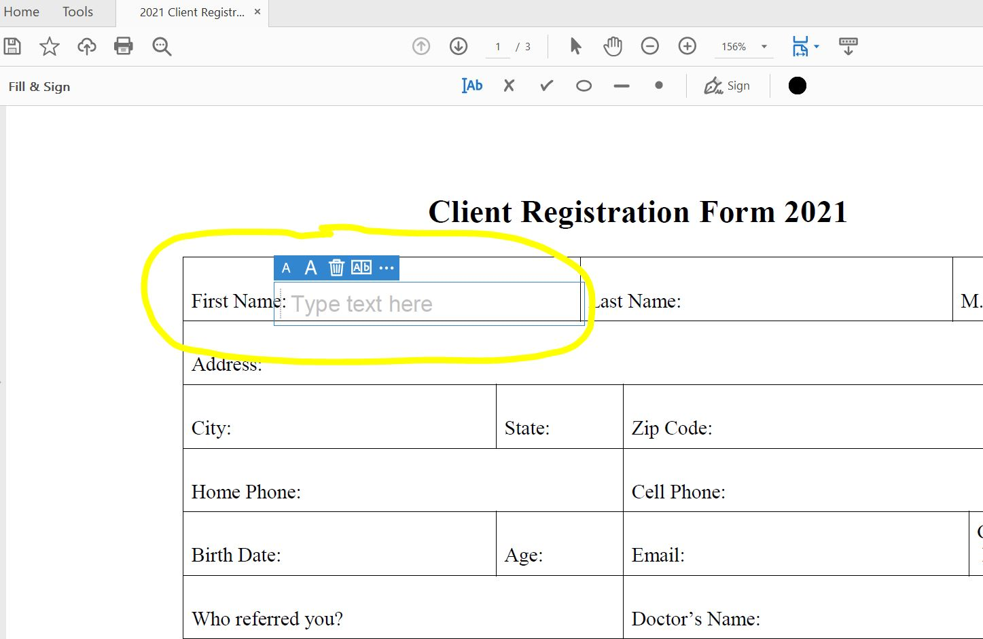
- You will now be able to fill in each field of information. Simply click within each box to type in your answer.

- Once you have clicked in each box and filled out the entire form, save by selecting File from the top menu bar, and Save As.

- Please email your forms to Terri at mindfulnessbalance@gmail.com, or print them out and bring with you to your next meeting.

